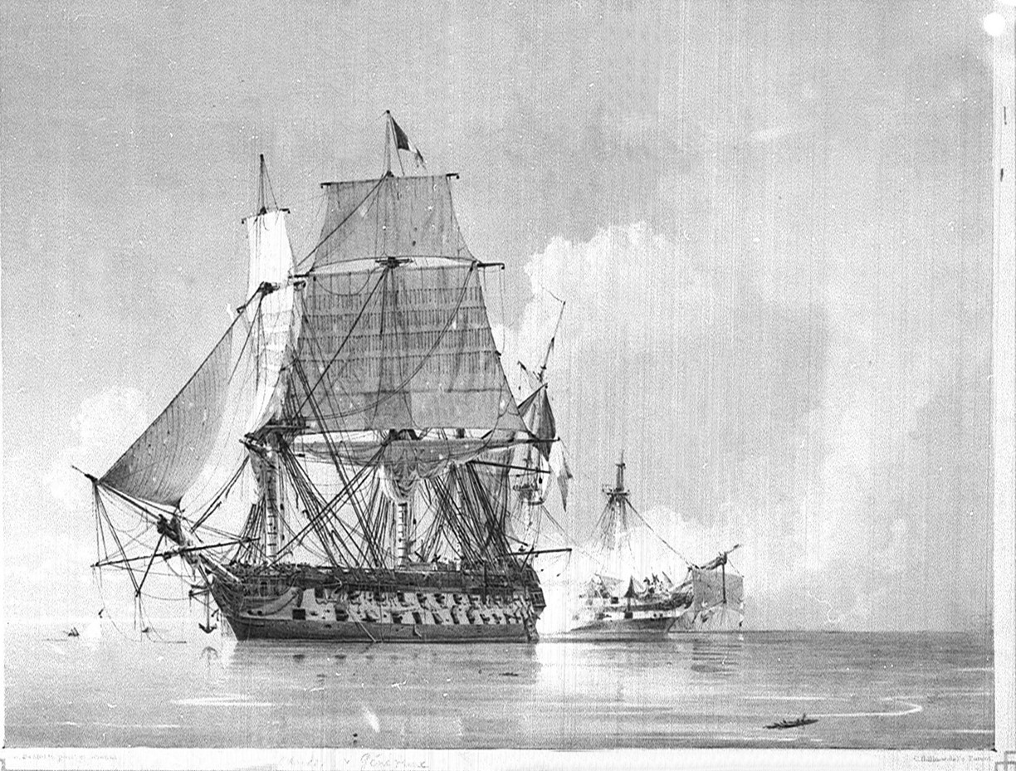
TASK 1 :
A warship does not begin at sea. It begins in a shipyard, in a year, in a nation that believed it could rule the waves. Find where she was built, where she fought her greatest battle, and where she struck next — before anyone could catch her.
Flag format : Securinets{creationdate_coords1_dateofwar_corrds2 _place}
Coords=lat,lon
The solver :
Securinets{1785_45.934,0.957_1798_31.300,30.166_crete}
TASK 2 :
After years at sea, the warship was eventually captured by a neighbore. Among the spoils taken from the ship there was one that survives today in a museum. Trace the events surrounding the ship’s capture and the fate of its belonging
Flag format : Securinets{nameisland_date_battle_itemSize1_itemSize2_people}
Ex :item Size=13.5m
The solver :
Securinets{lampedusa_1800_malta_convoy_16m_8.3m_norwich}

